Assignment

Unique Idea For Old Age People

* A simple UI Design for 65 and above Age group people

(Note : We can put Icons instead of text but in my case there is small issue for icons there is a website flaticon now they are charging each icon so I have written Text)

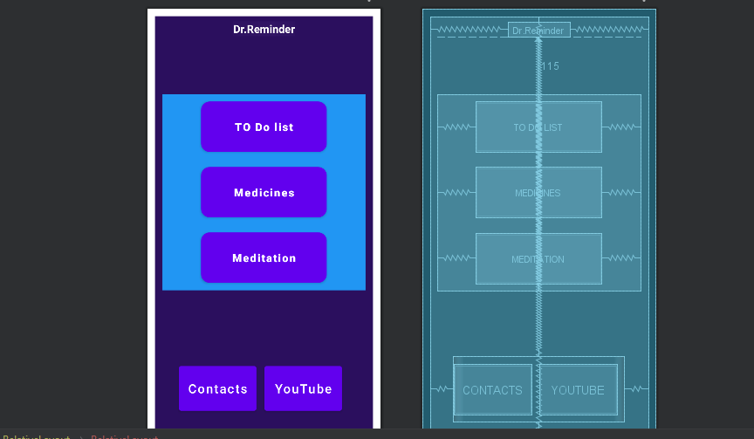

List of Buttons

* To Do list
* Medicines
* Meditation
* Contacts
* YouTube
* To Do List is a reminder(Notification on time with Checklist) list that contents on Daily Bases

(Note : Bellow reminder can set in one application that can be easy to a person to do all things on time)

1. Morning Meditation 10min
2. Morning Walk 15min
3. Rest 20min
4. Breakfast at 10 am
5. Lunch At 1pm
6. Evening Snacks 5pm
7. Dinner at 8pm to 8.30pm
8. Sleep Time 10 to 7

* Medicines

Set alarm as per user Requirements

* Meditation

Videos

* Contacts

Emergency Contact list

* YouTube

YouTube links for Meditation, Yoga and Retirement life.

One More notification on Hands sanitizing, Wear Mask

Code Screenshots

